**Property Indication**

1. **Property Information:**

|  |  |
| --- | --- |
| **Property Address:** | # A-39, St. A, Borey Arata, Phum Banhla Saert, S/k. Khmounh, Khan Sen Sok, Phnom Penh. |
| **Property Type** | A parcel of land accommodating an under-constructed a 3-storey Link House B. |
| **Front Road** | 8m |
| **Land Size** | 95sqm [as per project layout] |
| **Building Size:** | 5m x 12m = 60sqm* 3 floors = 180sqm [ as per project layout] |
| **Title Deed No:** | Will have hard title |
| **SPA** | USD124,155.00 |

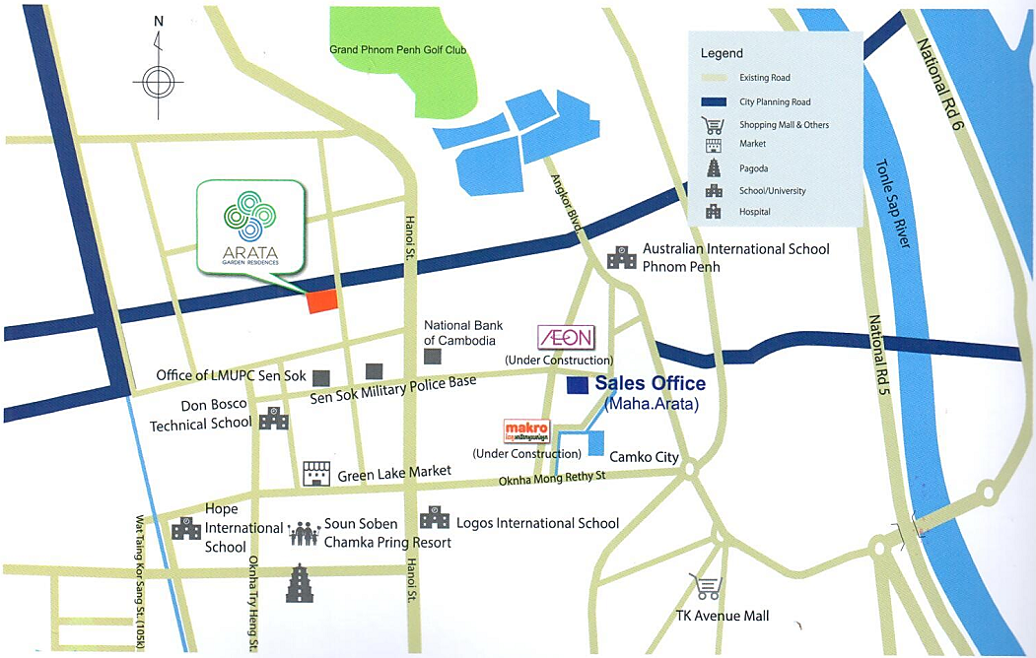

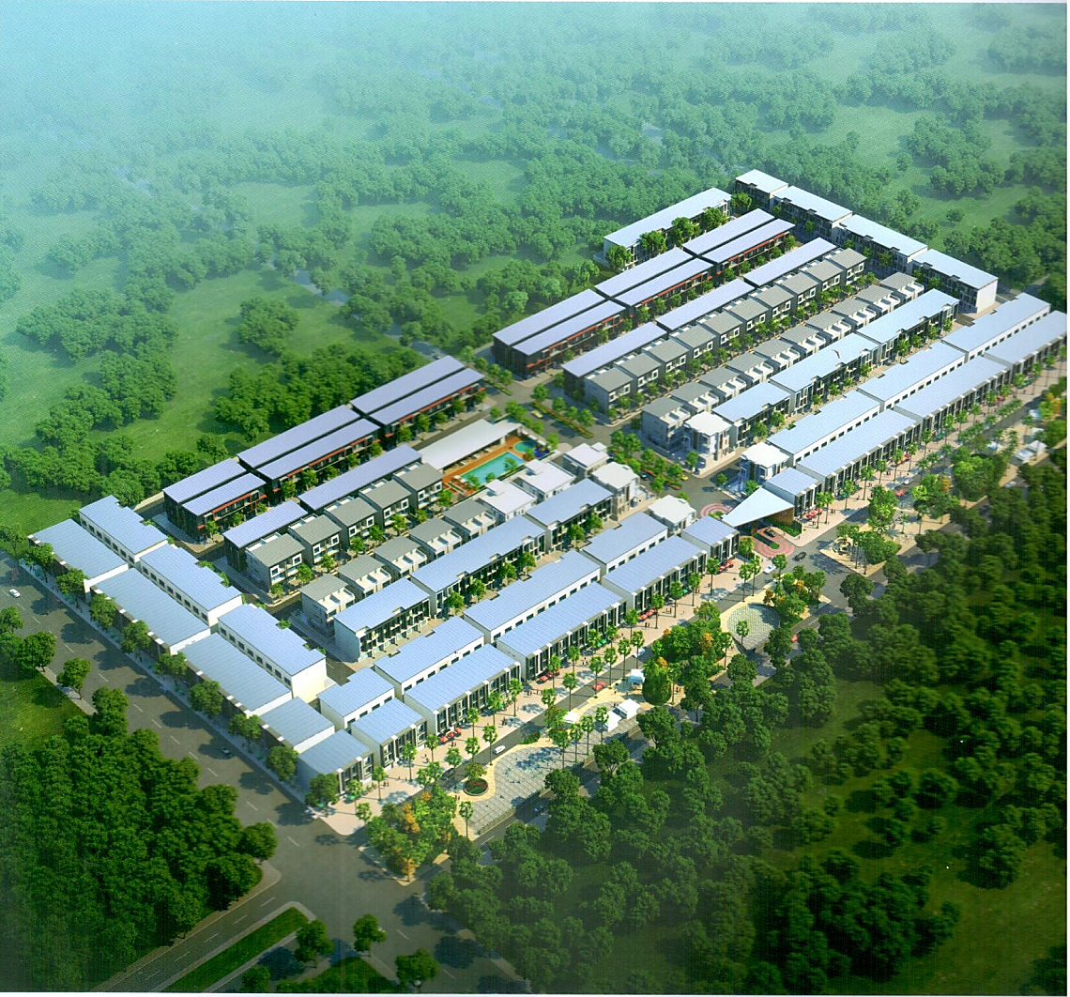

Subject property to be charged **A-39**

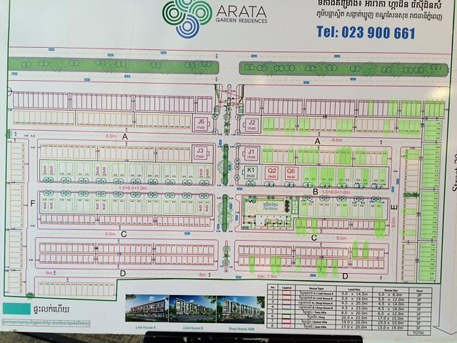

Subject property to be charged **A-39**

**Under Construction**

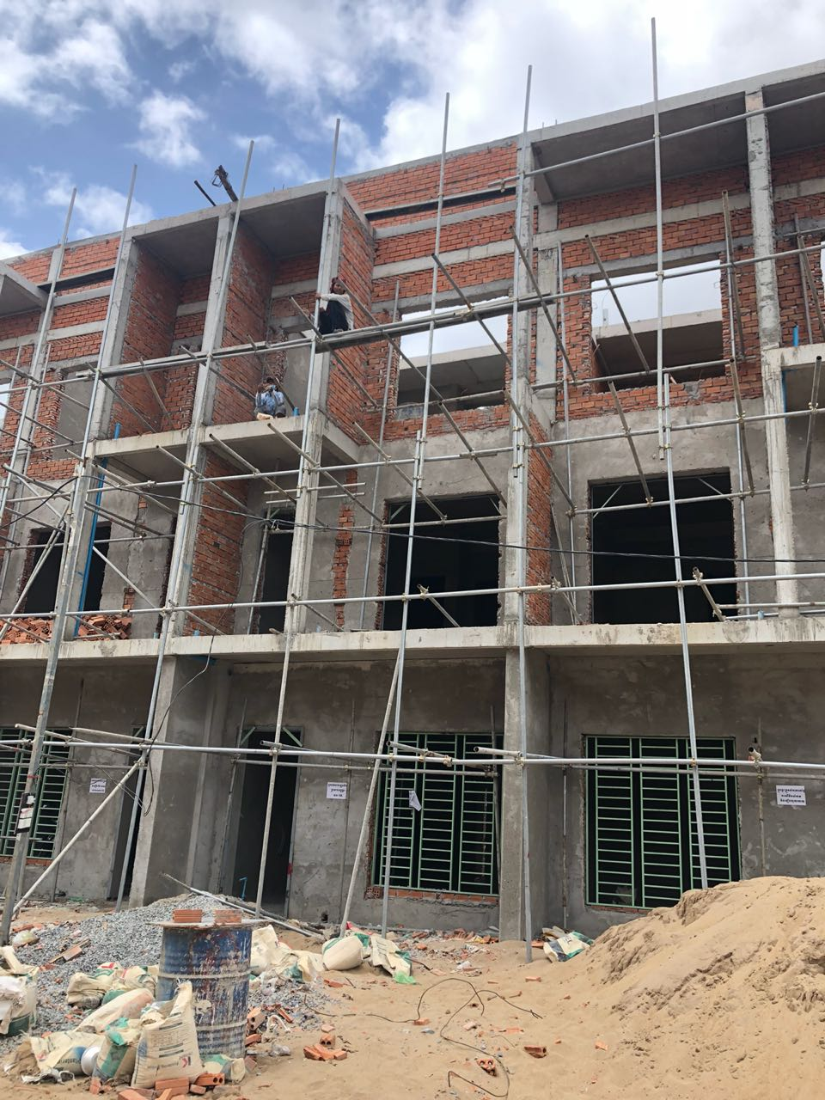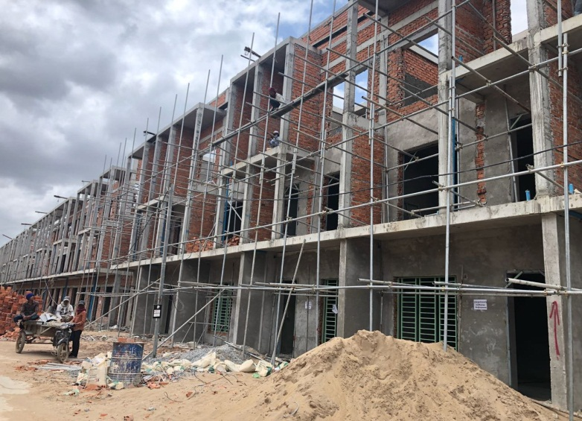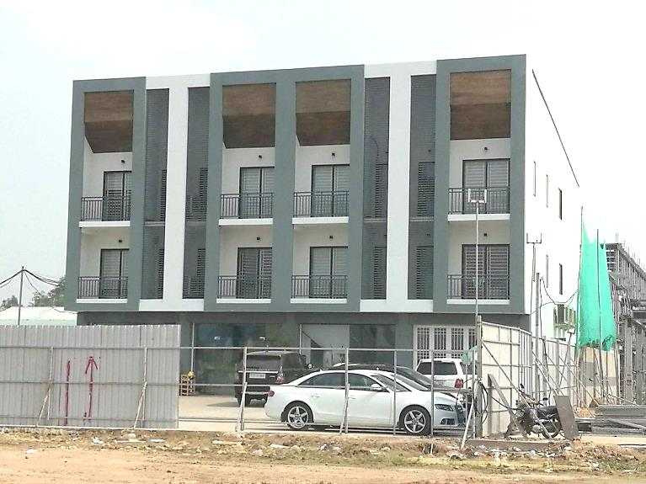

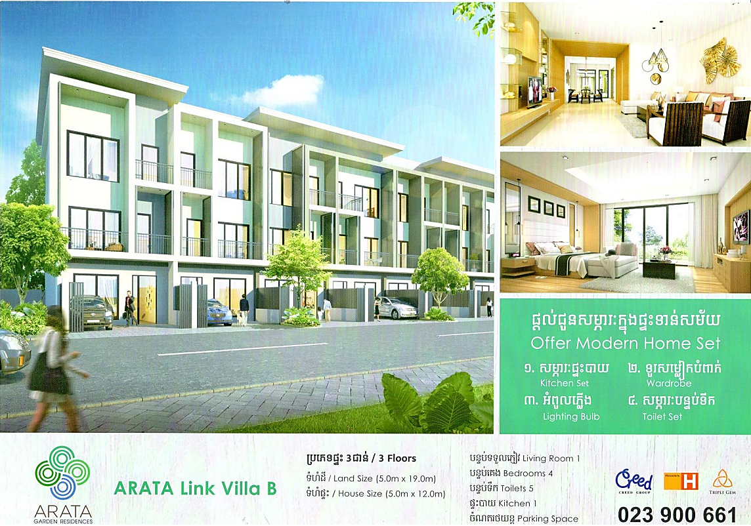

**Future Building**

